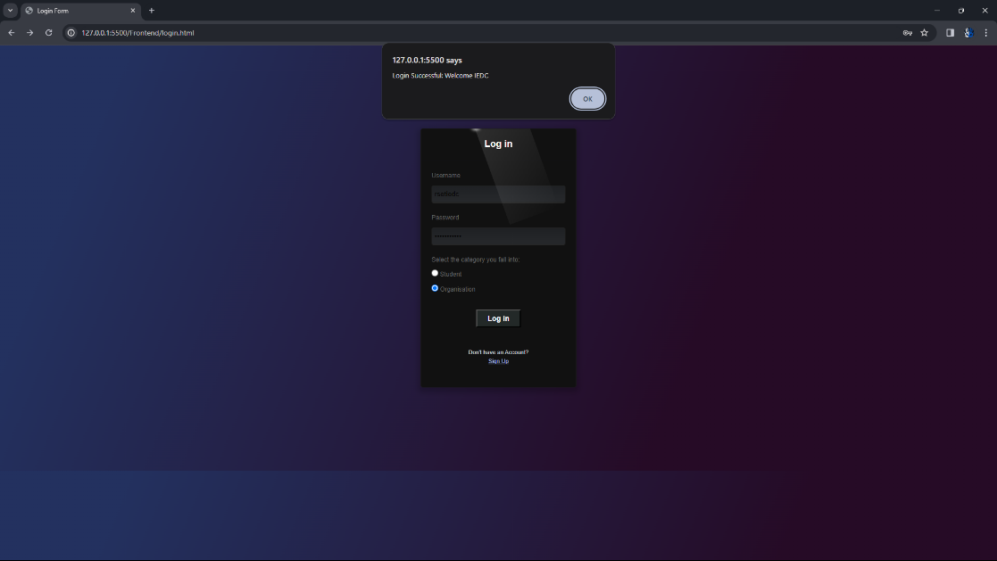

Fig 1

Fig 1 shows the login of an approved organisation named IEDC

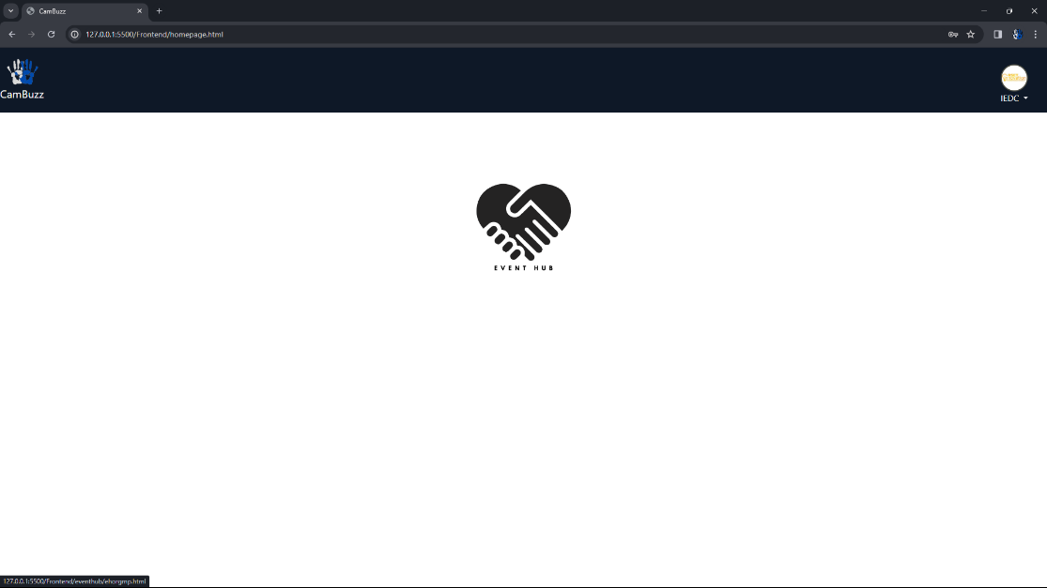

Fig 2

Fig 2 shows the main page for organisation. In this, unlike for students, onlt eventhub option is shown, as organsiations can only participate in eventhub functionalities

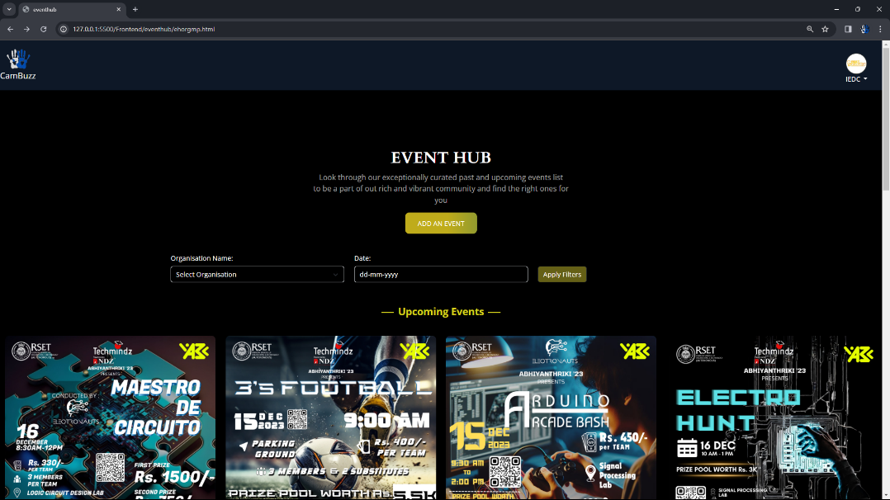

Fig 3

Fig 3 depicts main page of event hub for organisation. It lists all the events added by all organsiations as upcoming and past events.Users can filter it according to organsiation name or date of the event

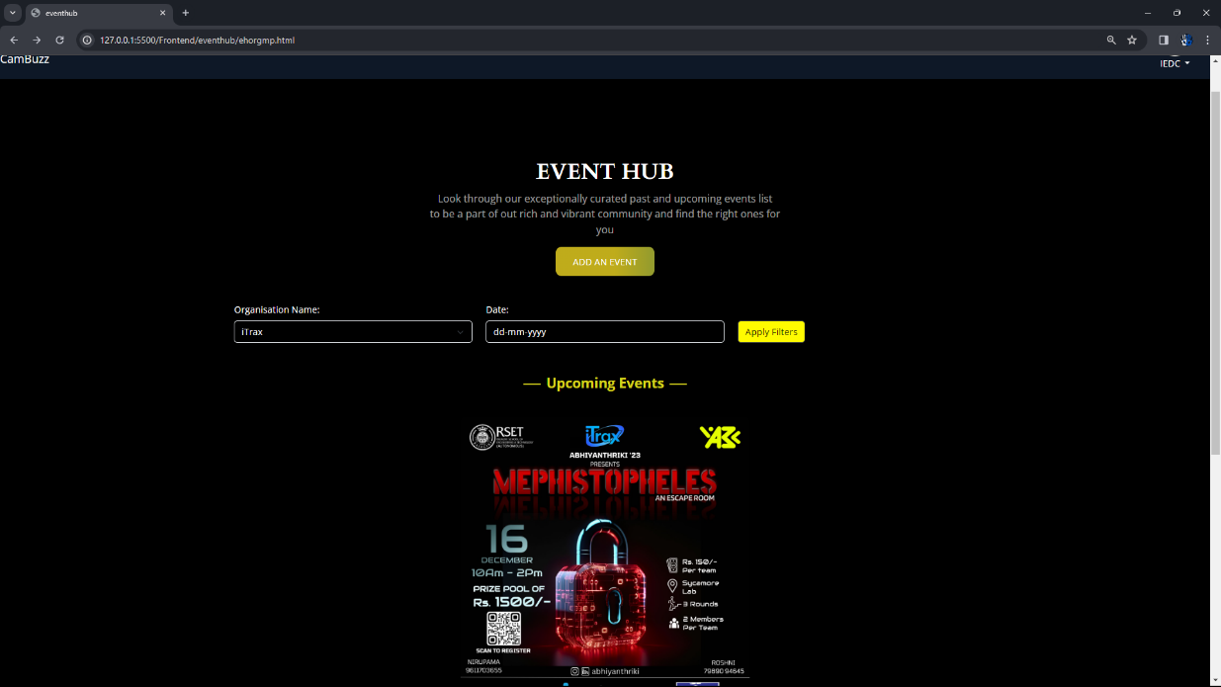

Fig 4

Fig 4 shows filtering of events based on name. In this, iTrax is selected as organsiation, it filters out iTrax;s events as upcoming and past events

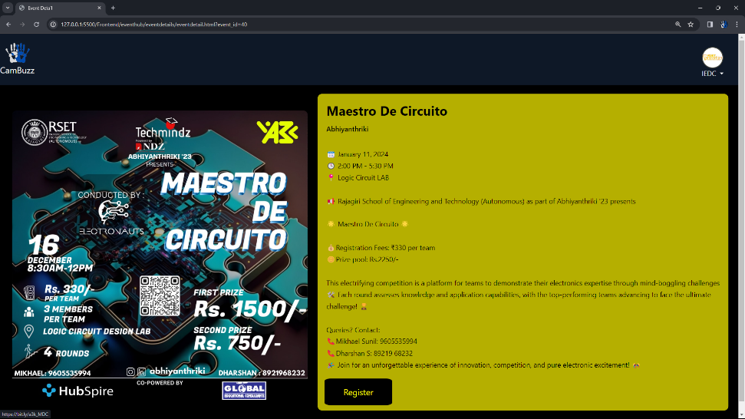

Fig 5

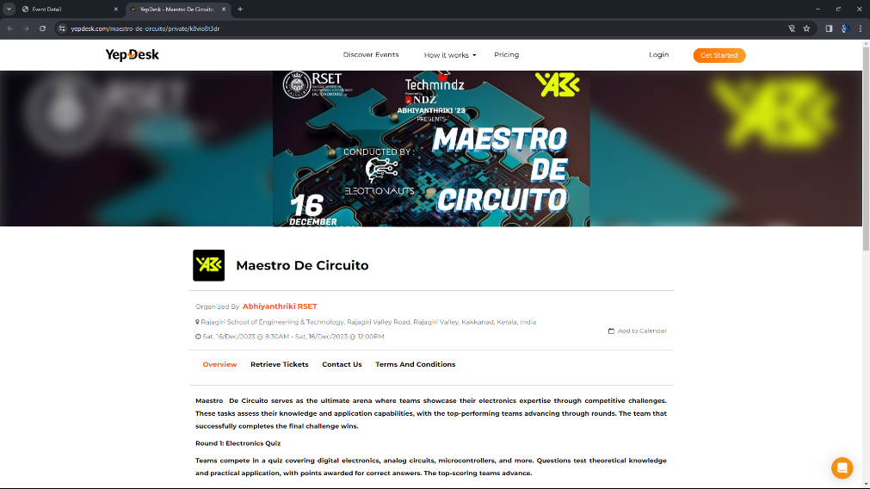

Fig 6

Fig 5 shows detailed view of an event when that particular event is selected form the event hub main page.It shows details added by the organsiation like dates, timimgs, venues etc. Users can directly register from this site using the register button

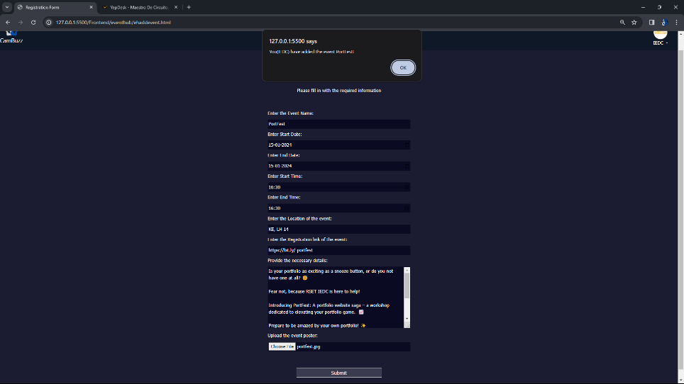

Fig 6

Fig 6 shows addition of an event by organistion when the add event button is clicked

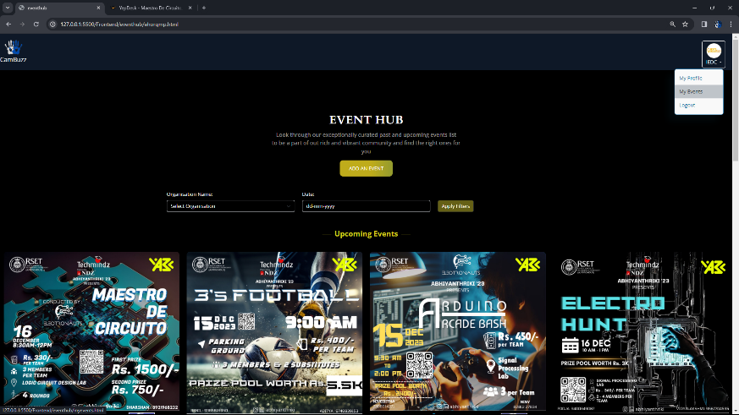

Fig 7

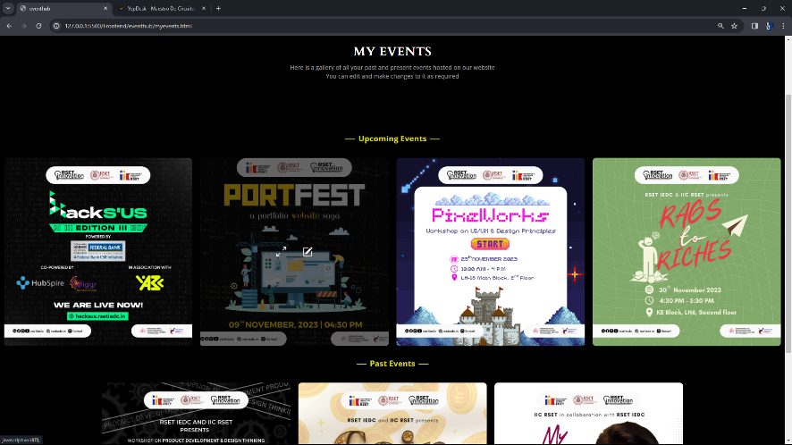

Fig 8

In fig 7, we can see that the dropdown menu of organisation only has my events options, which when clicked is redirected to my events page(Fig 8). This page lists all the events uploaded by that particular organisation

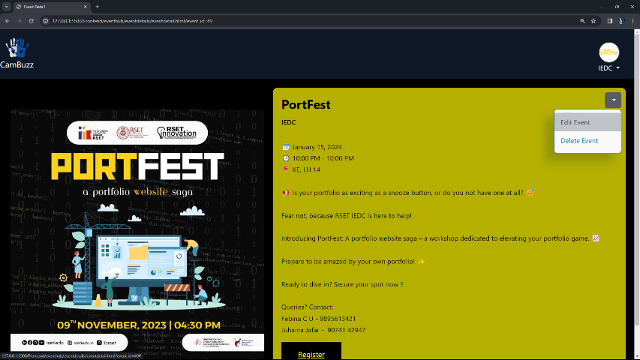

Fig 9

When clicked on the event uploaded by the current organisation user, it renders the same event details page as earlier, but, it shows an extra dropdown icon on the top right which enables the user to edit or delete that particular event. This is dynamically set

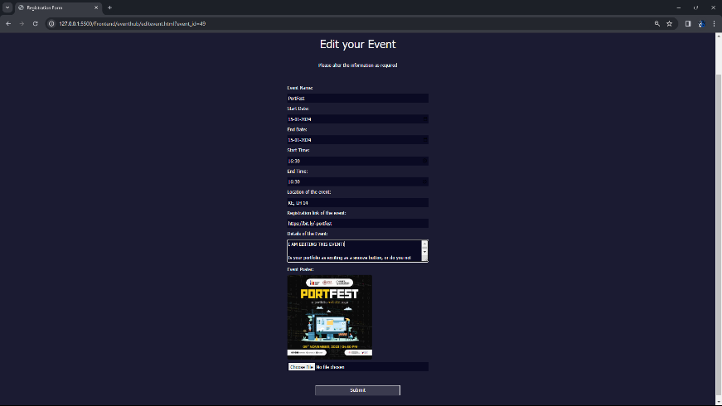

Fig 10

Fig 10 shows editing an event. The fields are automatically populated by the current details of that evet, which the organisation can edit

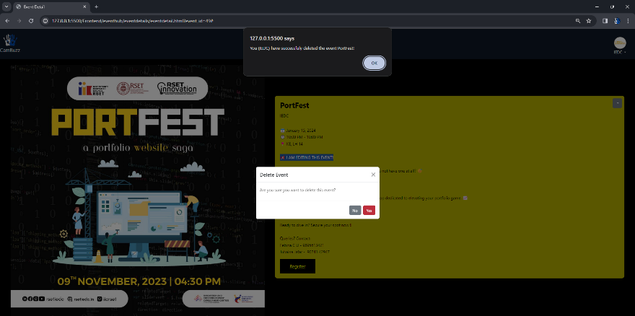

Fig 11

Fig 11 shows deletion of event

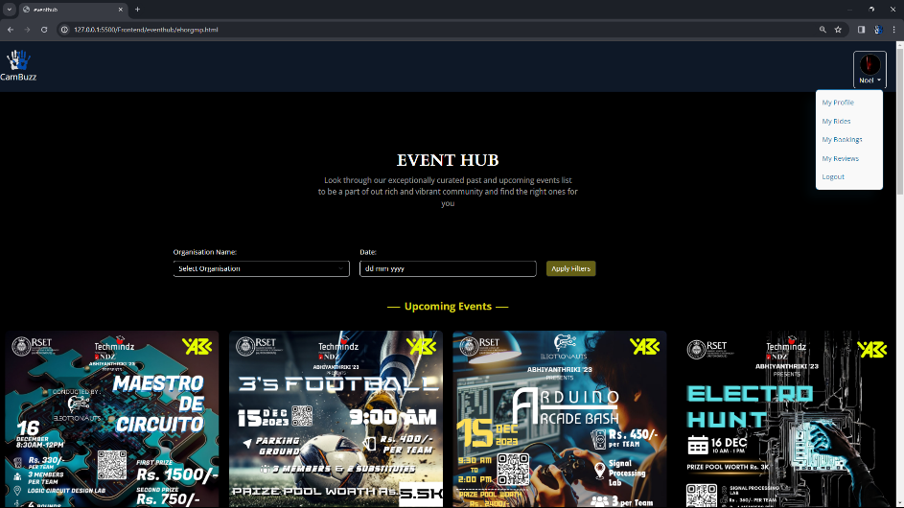

Fig 12

Fig 12 shows the evne hub page for student user. There is no add event button, as students can only view and register events

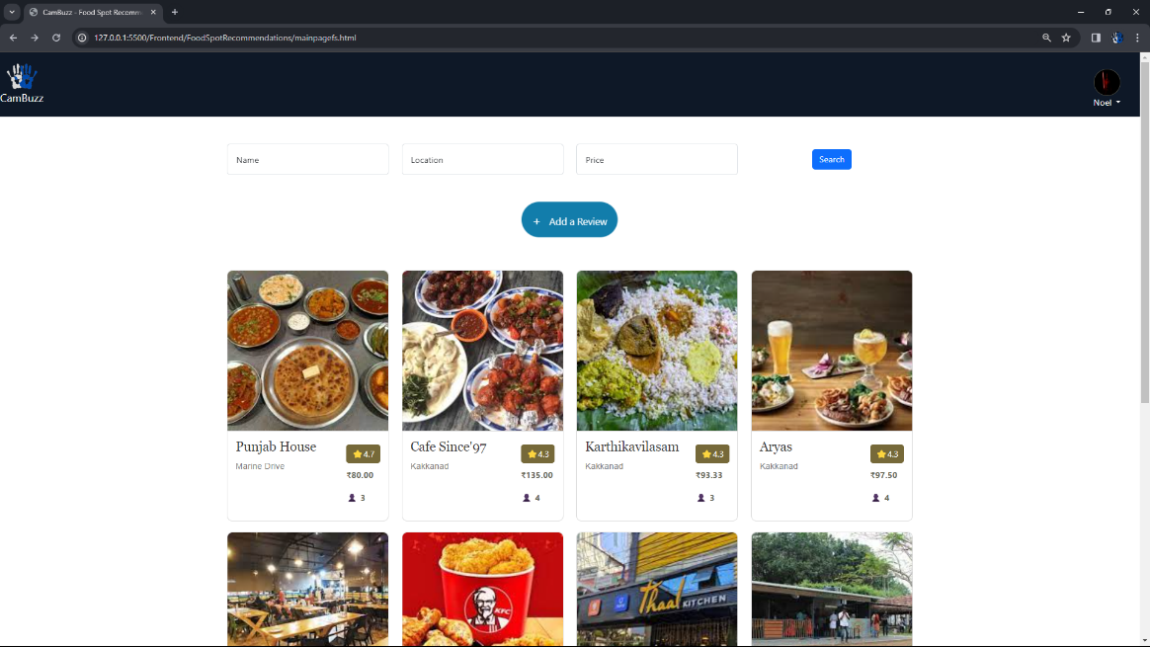

Fig 13

Fig 13 shows the main page of the module food spot review/recommendation. In this page, the students can view top reated restaurants added by other students. They can also filter the restaurants according to their name, location and avg price per head. The restaurant displayed in the decreasing order of their ratings. The page also has an add a review button which helps the students to add a review as they want

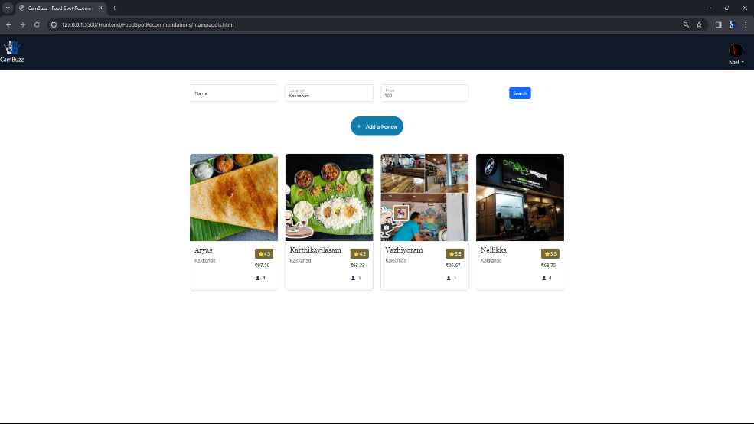

Fig 14

Fig 14 shows the restaurants are filtered wit location name as kakkanad

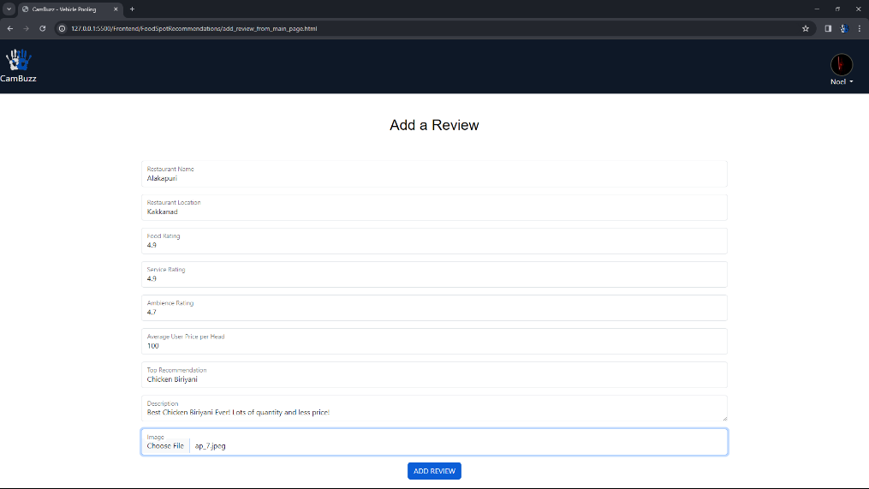

Fig 15

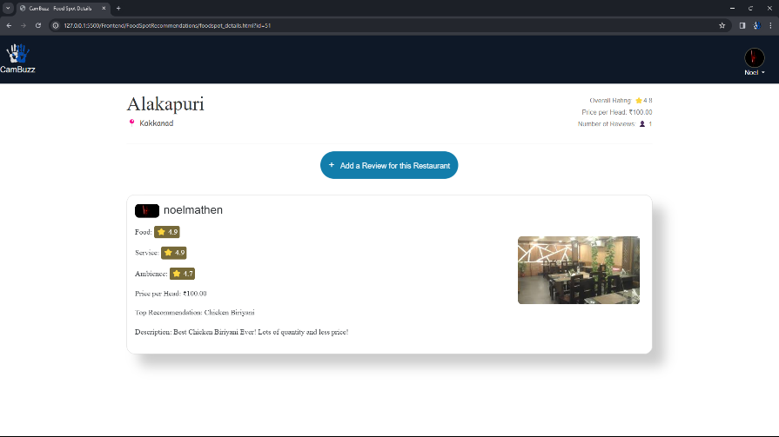

Fig 16

Fig 16 shows the page to add a review. In this, restaurant name, location along with its rating and pricing is inputted. Since Noel was the first one to create a reciew for Alakapuri, his review also created a newrestaurant. A restaurant will existg only if there is a review for it

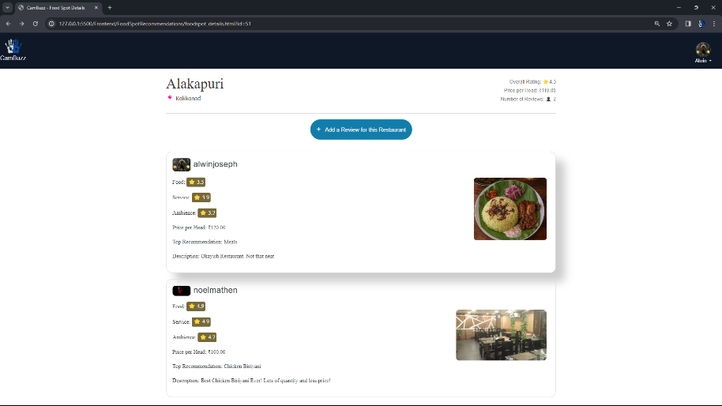

Fig 17(ITHU VENAM ENNILLA)

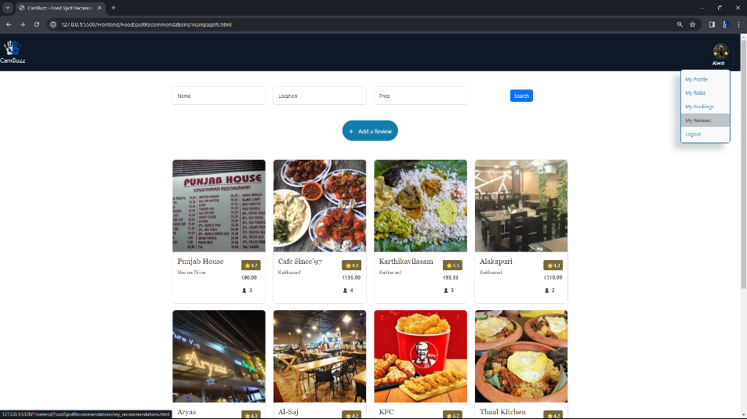

Fig 18

Fig 18 shows my the exisstance of my review button in the dropdown from navbar.

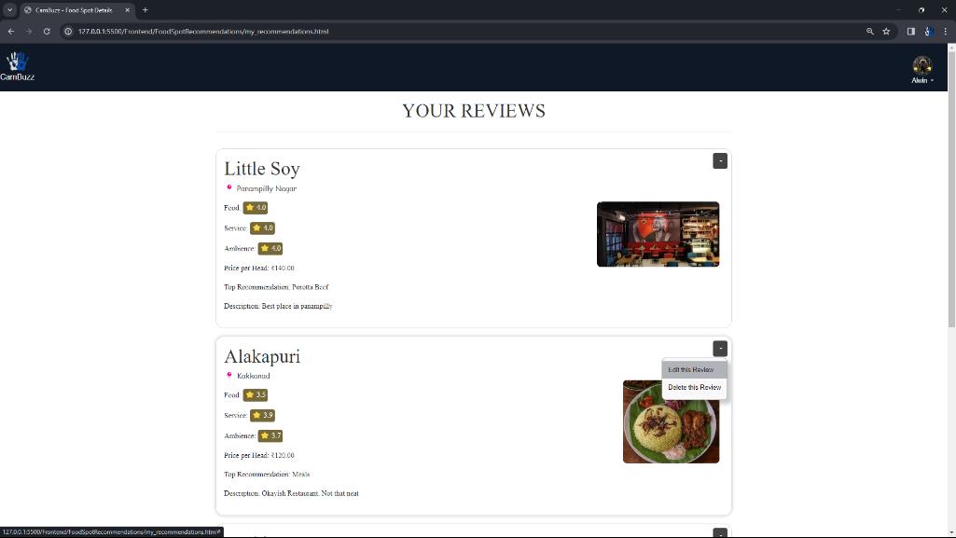

Fig 19

Fig19 shows your revies page, which lists all the reviews added by that particular person. For each review there is an edit/cancel button,where thestudent can edit thereview ordelete the review.

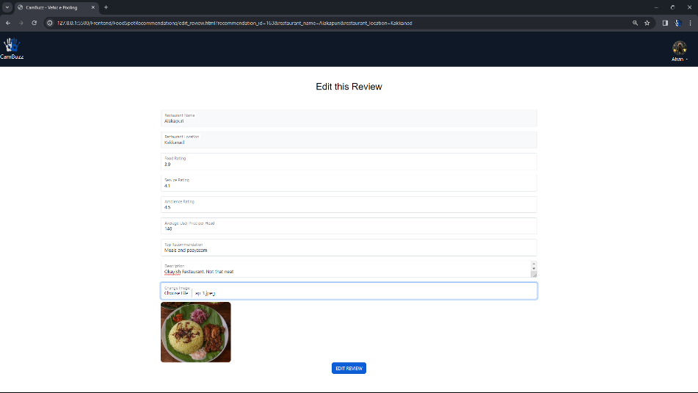

Fig 19

Fig 19 shows the edit page for review. The fields are automatically populated based on the review that was selected by the student

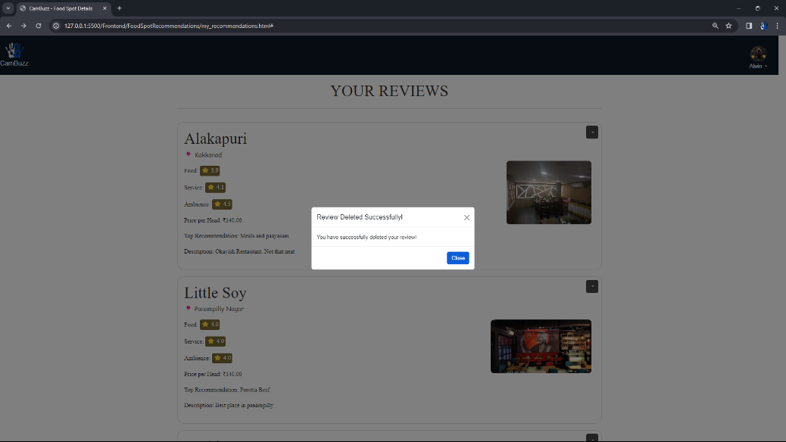

Fig 20

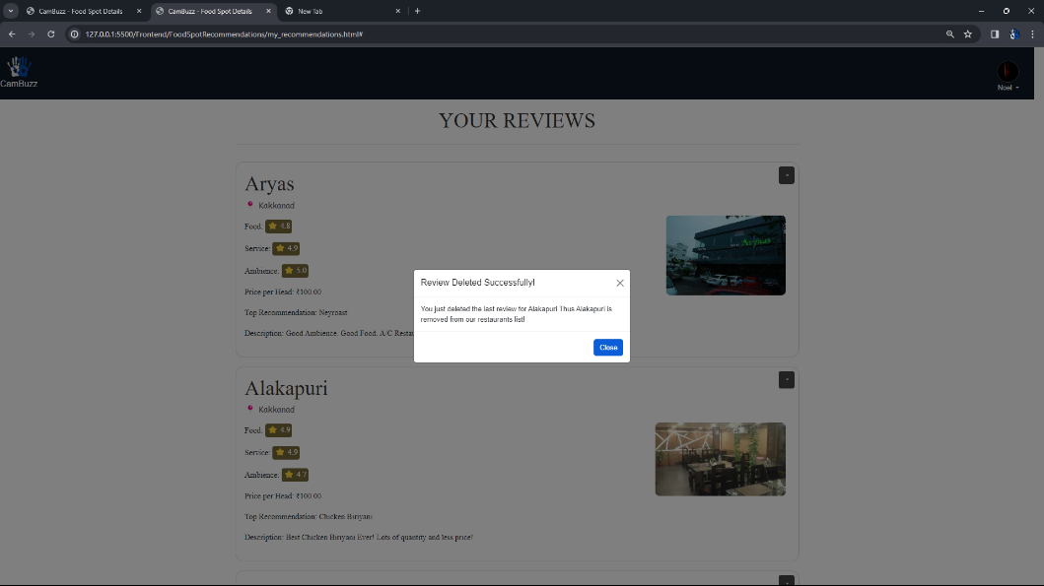

Fig 21

Fog 20 shows deletion of review by a Alwin. When Noel also deleted the review for Alakapuri, the restaurant is removed from the restauratns likst, since it has no suggestions

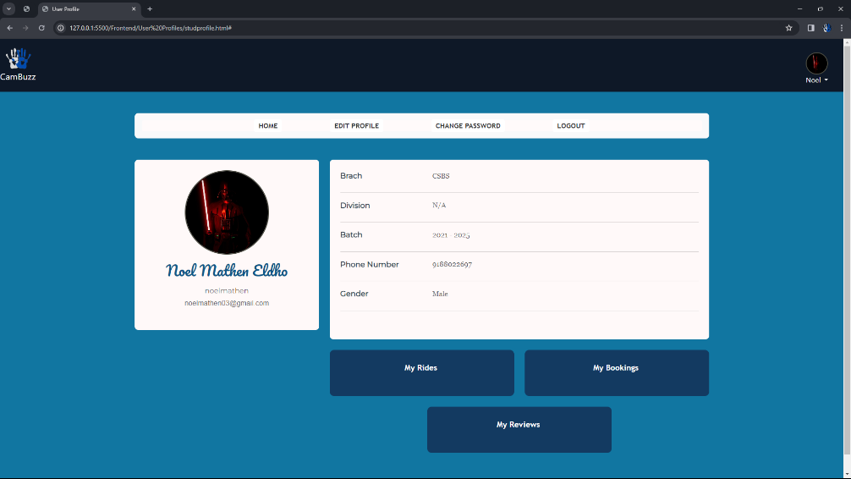

Fig 22

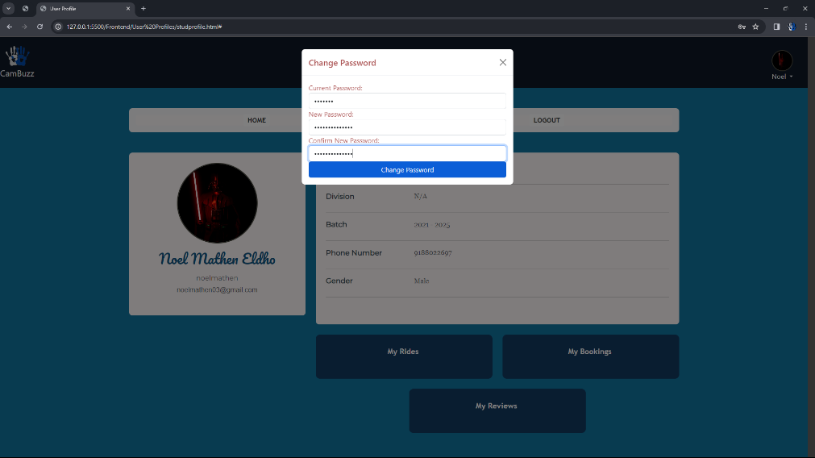

Fig 22

Fig 21 and 22 shows the profile page of a student user. The student related detilas are properly displayed, and it also has options like edit profile, change password, delete accounf and logout

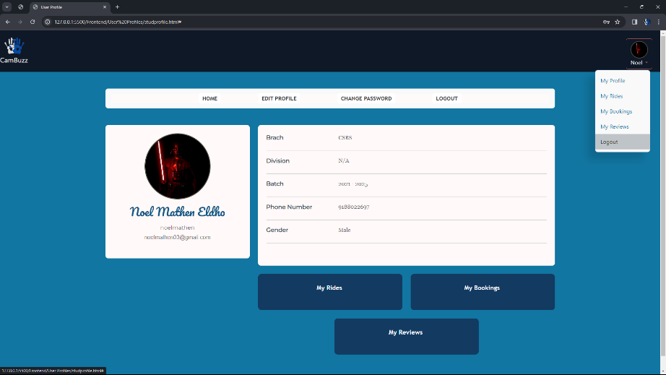

Fig 23

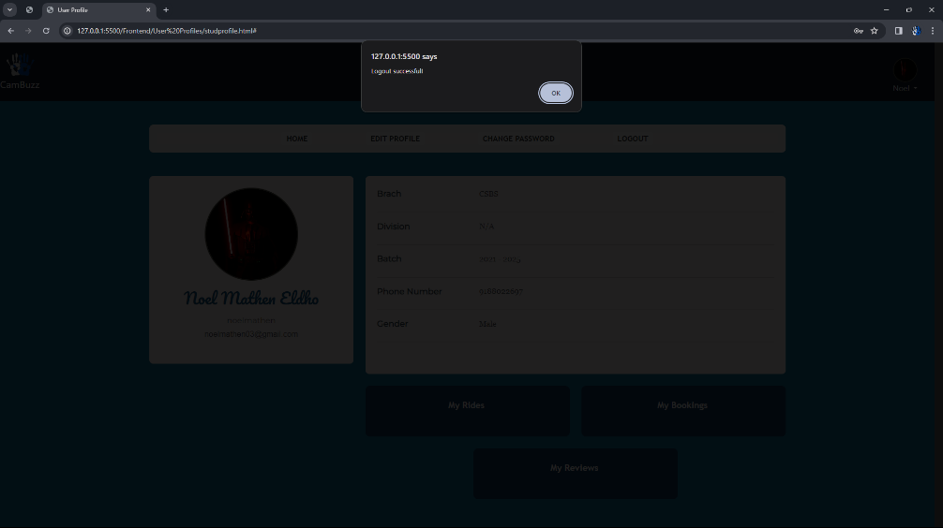

Fig 24

Fig 23 and 24 shows logout option in the navbar dropdown, so that a user(both student and organisation can lgout at any time)

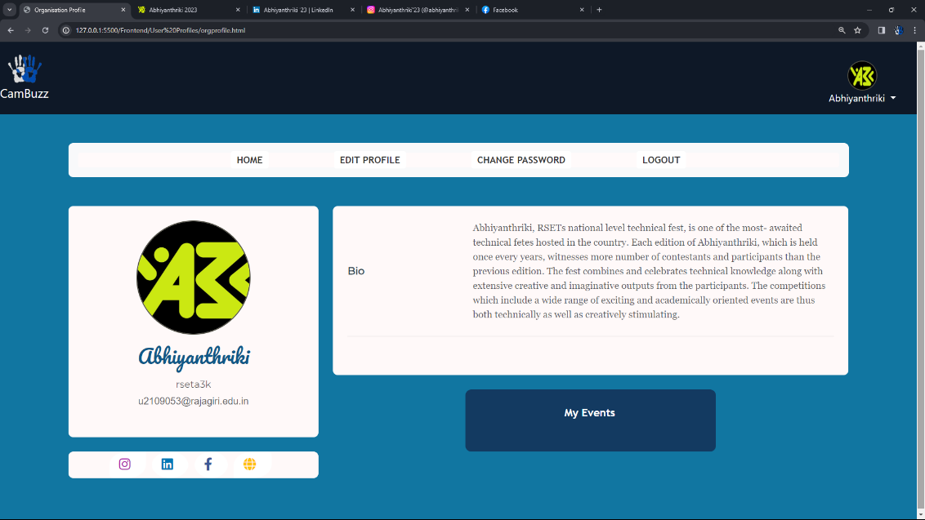

Fig 25

Fig 25 deptics the prifle page of organistion. It displays the the organsiation related details, along with the various social media links like Instagram, linkedin, faebook, which the organisation added during the time of its registration. It also has a reference to the My events page.

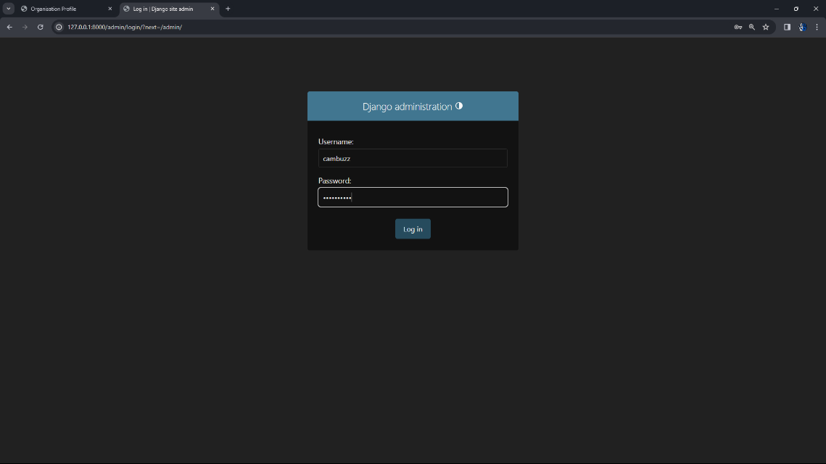

Fig 25

Fig 25 depicts the login page for admin in the djago admin panel..

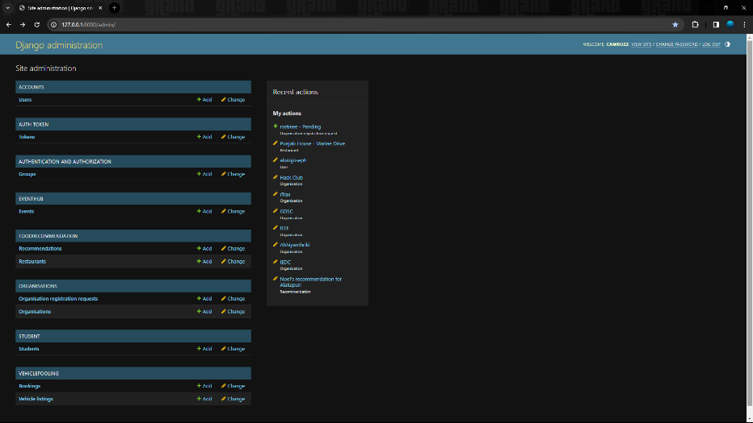

Fig 25

This is the list of all database tables that are in tis projects. For each object inside this table, the admin has access to alll functionalities like view/add/update/delete etc..

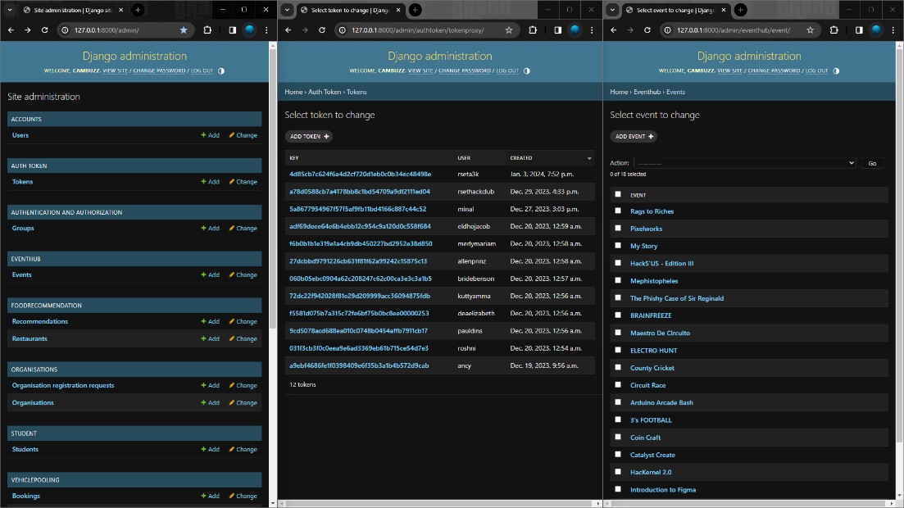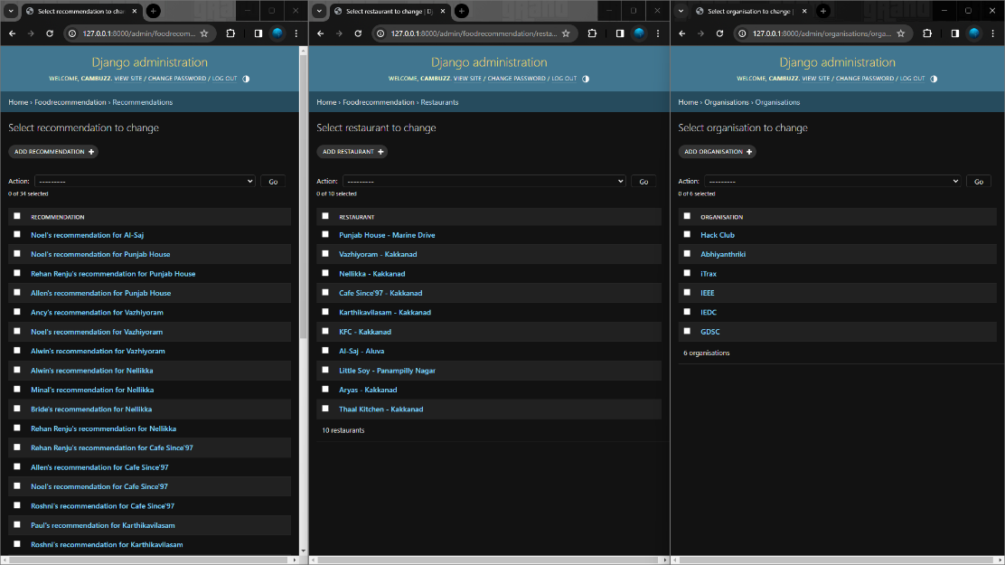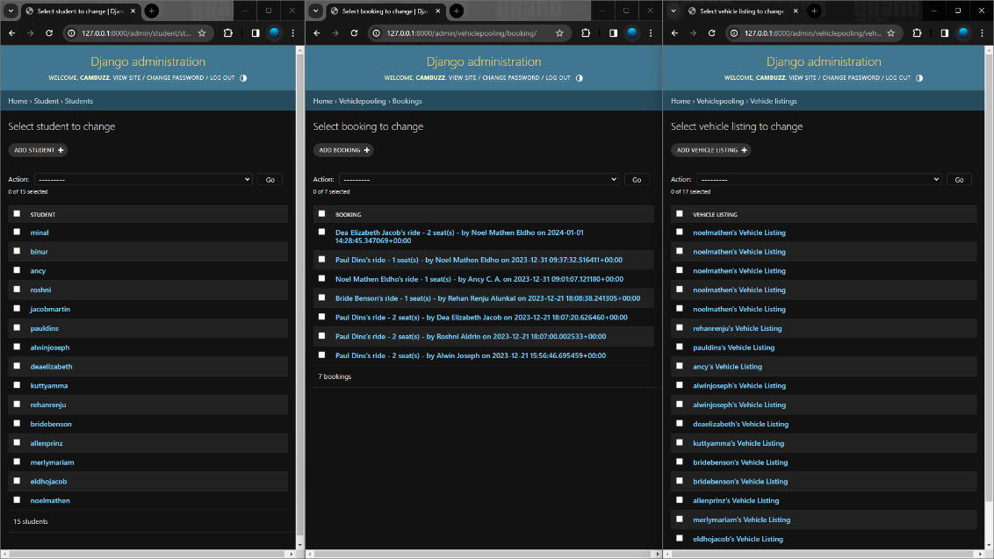

These 3 figures shws the current existing objects for each table.